Geometric Equality

Definition
# Source: AI Source: Provided by: [Data Path: Persons Table -> ID Column: 1, Name_En Column: Motasem Essam] -> From: [ChatGPT] on [7/25/2026]
Geometric Equality is a mathematical relationship in which two geometric quantities, measurements, objects, or expressions are exactly equal or equivalent according to specified geometric conditions.
The equality symbol is:
$$\boxed{=}$$
For example:
$$AB=CD$$
means that the lengths of segments $AB$and $CD$are exactly equal.
Geometric equality can describe equality of:
- lengths
- angles
- areas
- perimeters
- distances
- radii
- diameters
- volumes
- ratios
- geometric expressions
- corresponding parts of congruent or similar figures.
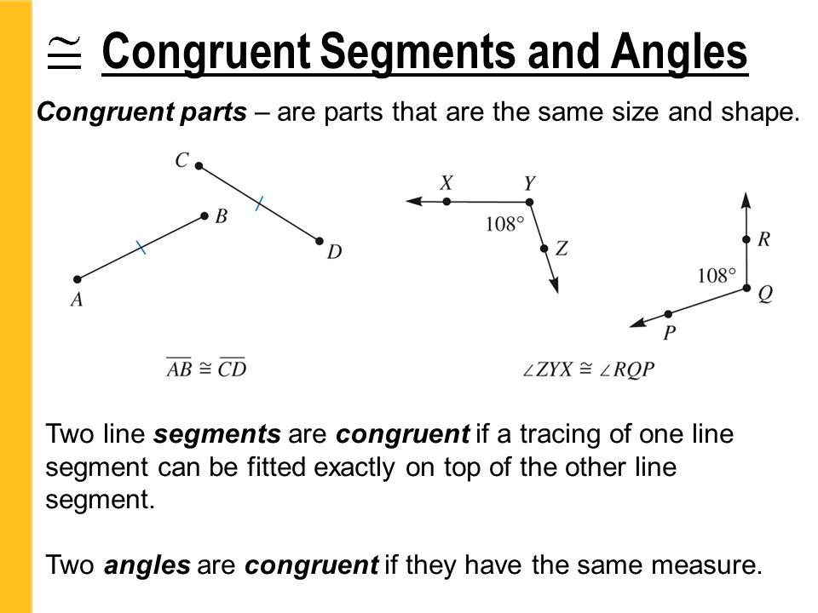
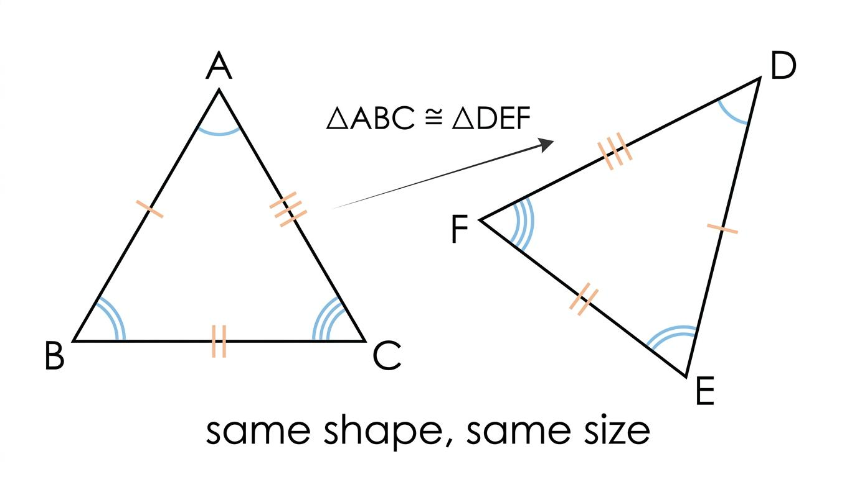
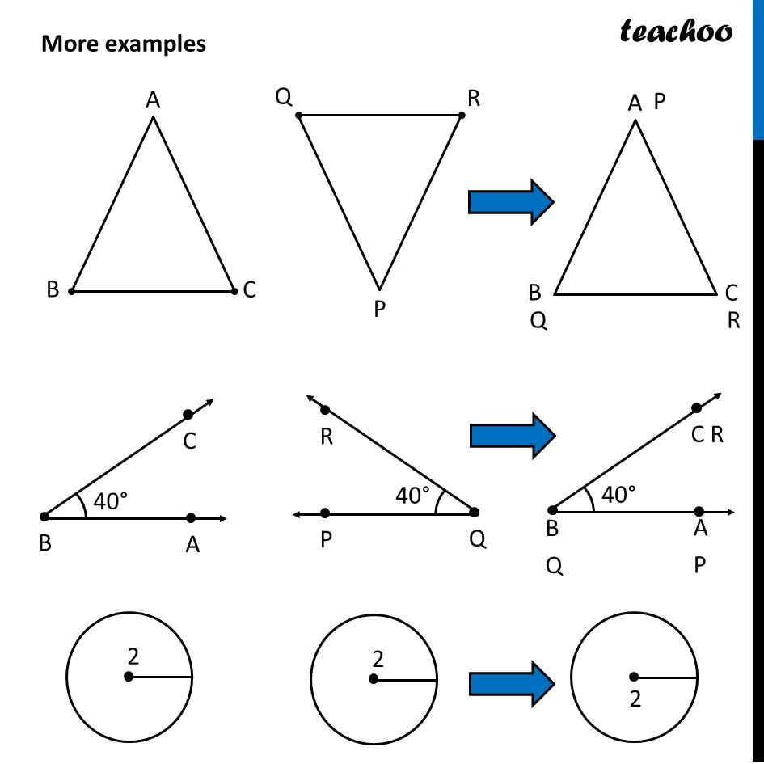
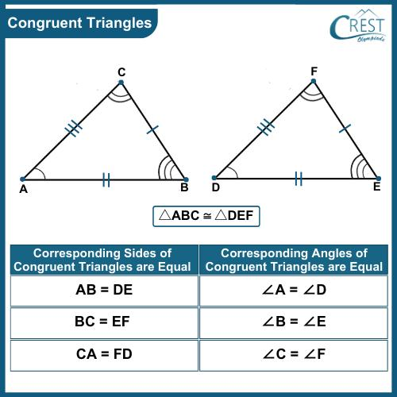
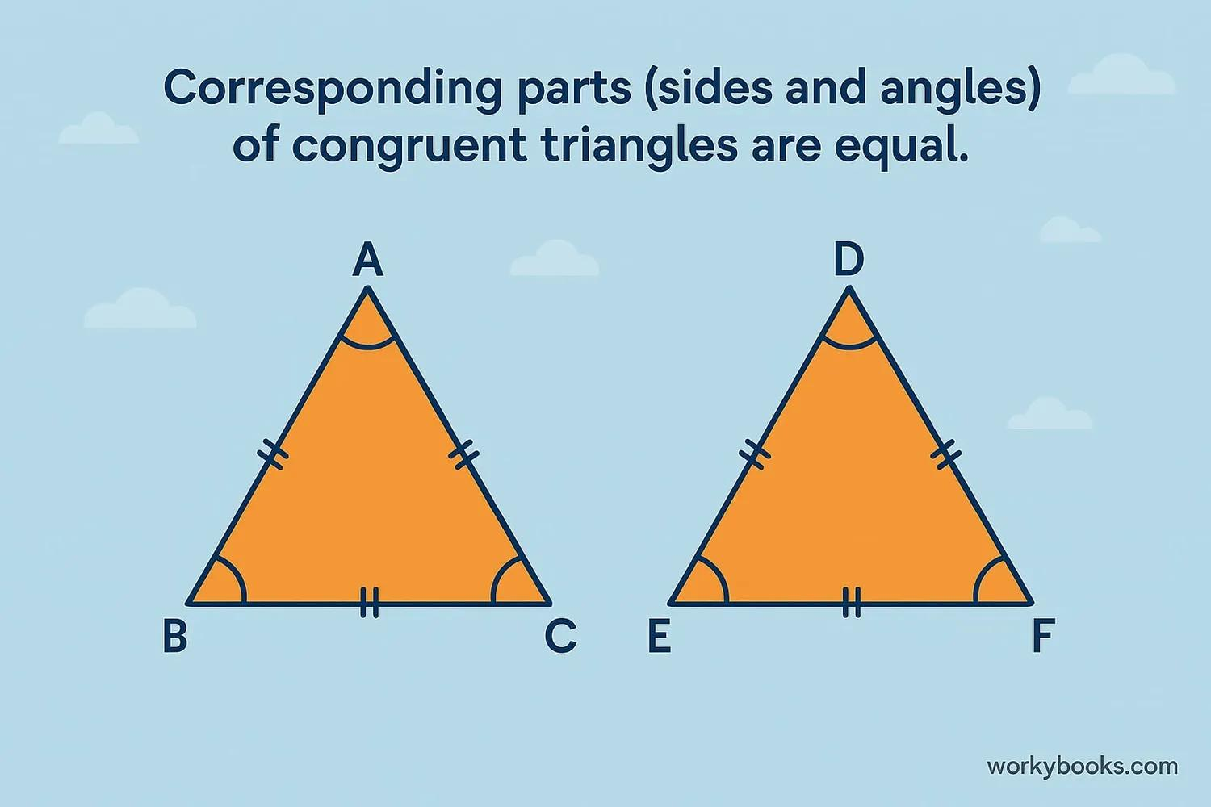

Simple Definition
# Source: AI Source: Provided by: [Data Path: Persons Table -> ID Column: 1, Name_En Column: Motasem Essam] -> From: [ChatGPT] on [7/25/2026]
Geometric equality states that two geometric quantities or expressions have exactly the same value or satisfy the same geometric relationship.
For example:
$$∠A=∠B$$
means the two angles have equal measures.

Fundamental Concept
# Source: AI Source: Provided by: [Data Path: Persons Table -> ID Column: 1, Name_En Column: Motasem Essam] -> From: [ChatGPT] on [7/25/2026]
A geometric equality can be represented as:
$$\boxed{{\text{Geometric Object or Quantity}}_{1}={\text{Geometric Object or Quantity}}_{2}}$$
Examples:
Equal lengths
$$AB=CD$$
Equal angles
$$m∠A=m∠B$$
Equal areas
$$\left[ABC\right]=\left[DEF\right]$$
Equal perimeters
$$P_{1}=P_{2}$$
Equal distances
$$PA=PB$$
The important idea is that the two quantities have exactly the same mathematical value under the stated conditions.

Main Types of Geometric Equality
# Source: AI Source: Provided by: [Data Path: Persons Table -> ID Column: 1, Name_En Column: Motasem Essam] -> From: [ChatGPT] on [7/25/2026]
A practical classification is:
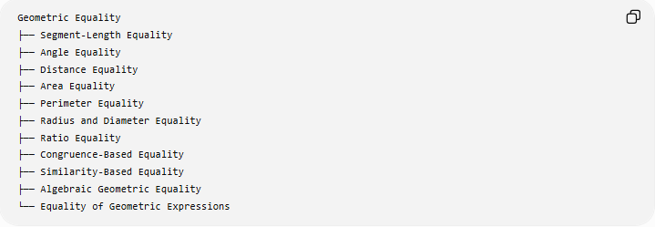
Geometric Equality
├── Segment-Length Equality
├── Angle Equality
├── Distance Equality
├── Area Equality
├── Perimeter Equality
├── Radius and Diameter Equality
├── Ratio Equality
├── Congruence-Based Equality
├── Similarity-Based Equality
├── Algebraic Geometric Equality
└── Equality of Geometric Expressions
These categories can overlap. For example, congruent triangles produce several segment-length and angle equalities.

Segment-Length Equality

Definition
# Source: AI Source: Provided by: [Data Path: Persons Table -> ID Column: 1, Name_En Column: Motasem Essam] -> From: [ChatGPT] on [7/25/2026]
Segment-length equality occurs when two line segments have exactly the same length.
$$\boxed{AB=CD}$$

Example
# Source: AI Source: Provided by: [Data Path: Persons Table -> ID Column: 1, Name_En Column: Motasem Essam] -> From: [ChatGPT] on [7/25/2026]
If:
$$AB=7\text{ cm}$$
and:
$$CD=7\text{ cm}$$
then:
$$\boxed{AB=CD}$$
The segments do not have to occupy the same position or have the same direction. Their lengths are equal.

Important distinction
# Source: AI Source: Provided by: [Data Path: Persons Table -> ID Column: 1, Name_En Column: Motasem Essam] -> From: [ChatGPT] on [7/25/2026]
Equal segments are not necessarily the same geometric segment.
For example:
$$AB=CD$$
does not mean:
$$\overset{‾}{AB}=\overset{‾}{CD}$$
as the same physical segment. It means their lengths are equal.

Angle Equality

Definition
# Source: AI Source: Provided by: [Data Path: Persons Table -> ID Column: 1, Name_En Column: Motasem Essam] -> From: [ChatGPT] on [7/25/2026]
Angle equality occurs when two angles have the same measure.
$$\boxed{m∠A=m∠B}$$
Example
If:
$$m∠A={60}^{∘}$$
and:
$$m∠B={60}^{∘}$$
then:
$$\boxed{∠A=∠B}$$

Common sources
# Source: AI Source: Provided by: [Data Path: Persons Table -> ID Column: 1, Name_En Column: Motasem Essam] -> From: [ChatGPT] on [7/25/2026]
Angle equality can result from:
- vertical angles
- angle bisectors
- corresponding angles
- alternate interior angles
- alternate exterior angles
- congruent triangles
- isosceles triangles
- equilateral triangles.

Distance Equality

Definition
# Source: AI Source: Provided by: [Data Path: Persons Table -> ID Column: 1, Name_En Column: Motasem Essam] -> From: [ChatGPT] on [7/25/2026]
Distance equality states that two distances are exactly equal.
For example:
$$PA=PB$$
means point $P$is equally distant from $A$and $B$.

Example
# Source: AI Source: Provided by: [Data Path: Persons Table -> ID Column: 1, Name_En Column: Motasem Essam] -> From: [ChatGPT] on [7/25/2026]
If:
$$PA=6\text{ cm}$$
and:
$$PB=6\text{ cm}$$
then:
$$\boxed{PA=PB}$$
This type of equality is fundamental to locus geometry.
For example:
$$PA=PB$$
describes the set of points equidistant from $A$and $B$, which is the perpendicular bisector of $\overset{‾}{AB}$.

Area Equality

Definition
# Source: AI Source: Provided by: [Data Path: Persons Table -> ID Column: 1, Name_En Column: Motasem Essam] -> From: [ChatGPT] on [7/25/2026]
Area equality occurs when two geometric regions have exactly the same area.
$$\boxed{A_{1}=A_{2}}$$

Example
# Source: AI Source: Provided by: [Data Path: Persons Table -> ID Column: 1, Name_En Column: Motasem Essam] -> From: [ChatGPT] on [7/25/2026]
A rectangle with dimensions:
$$4×6$$
has area:
$$A=24$$
A triangle with base $8$and height $6$has area:
$$A=\frac{1}{2}\left(8\right)\left(6\right)=24$$
Therefore:
$$\boxed{A_{\text{rectangle}}=A_{\text{triangle}}=24}$$
The figures have different shapes but equal areas.

Perimeter Equality

Definition
# Source: AI Source: Provided by: [Data Path: Persons Table -> ID Column: 1, Name_En Column: Motasem Essam] -> From: [ChatGPT] on [7/25/2026]
Perimeter equality means that two geometric figures have exactly the same total boundary length.
$$\boxed{P_{1}=P_{2}}$$

Example
# Source: AI Source: Provided by: [Data Path: Persons Table -> ID Column: 1, Name_En Column: Motasem Essam] -> From: [ChatGPT] on [7/25/2026]
A square with side:
$$s=5$$
has:
$$P=4\left(5\right)=20$$
A rectangle with dimensions $6×4$has:
$$P=2\left(6+4\right)=20$$
Therefore:
$$\boxed{P_{\text{square}}=P_{\text{rectangle}}=20}$$
The figures have equal perimeters but different areas:
$$25≠24$$

Radius Equality

Definition
# Source: AI Source: Provided by: [Data Path: Persons Table -> ID Column: 1, Name_En Column: Motasem Essam] -> From: [ChatGPT] on [7/25/2026]
A radius equality occurs when radii of circles are equal.
For a circle centered at $O$:
$$OA=OB=OC=r$$
Every radius of the same circle has the same length.

Example
# Source: AI Source: Provided by: [Data Path: Persons Table -> ID Column: 1, Name_En Column: Motasem Essam] -> From: [ChatGPT] on [7/25/2026]
If $A,B,C$lie on a circle centered at $O$, then:
$$\boxed{OA=OB=OC}$$
This equality is fundamental to many circle proofs.

Diameter Equality
# Source: AI Source: Provided by: [Data Path: Persons Table -> ID Column: 1, Name_En Column: Motasem Essam] -> From: [ChatGPT] on [7/25/2026]
Since:
$$d=2r$$
all diameters of the same circle have equal lengths.
If $AB$and $CD$are diameters:
$$\boxed{AB=CD}$$
Example
If:
$$r=5\text{ cm}$$
then every diameter has length:
$$d=2\left(5\right)=10\text{ cm}$$
Therefore:
$$\boxed{AB=CD=10\text{ cm}}$$

Ratio Equality

Definition
# Source: AI Source: Provided by: [Data Path: Persons Table -> ID Column: 1, Name_En Column: Motasem Essam] -> From: [ChatGPT] on [7/25/2026]
Ratio equality occurs when two ratios have exactly the same value.
For example:
$$\boxed{\frac{AB}{BC}=\frac{DE}{EF}}$$
This is especially important in similarity geometry.

Example
# Source: AI Source: Provided by: [Data Path: Persons Table -> ID Column: 1, Name_En Column: Motasem Essam] -> From: [ChatGPT] on [7/25/2026]
Suppose:
$$AB=6, BC=9$$
and:
$$DE=10, EF=15$$
Then:
$$\frac{AB}{BC}=\frac{6}{9}=\frac{2}{3}$$
and:
$$\frac{DE}{EF}=\frac{10}{15}=\frac{2}{3}$$
Therefore:
$$\boxed{\frac{AB}{BC}=\frac{DE}{EF}}$$

Equality from Congruence
# Source: AI Source: Provided by: [Data Path: Persons Table -> ID Column: 1, Name_En Column: Motasem Essam] -> From: [ChatGPT] on [7/25/2026]
Definition
Congruence establishes equality of corresponding measurements.
If:
$$△ABC≅△DEF$$
then corresponding sides and angles are equal.
For example:
$$\boxed{AB=DE} \\ \boxed{BC=EF} \\ \boxed{AC=DF}$$
and:
$$\boxed{∠A=∠D} \\ \boxed{∠B=∠E} \\ \boxed{∠C=∠F}$$
This follows from CPCTC:
Corresponding Parts of Congruent Triangles are Congruent.

Equality from Similarity
# Source: AI Source: Provided by: [Data Path: Persons Table -> ID Column: 1, Name_En Column: Motasem Essam] -> From: [ChatGPT] on [7/25/2026]
Similarity does not generally produce equality of corresponding side lengths.
Instead, it produces equal corresponding angles and equal ratios of corresponding sides.
If:
$$△ABC∼△DEF$$
then:
$$\boxed{∠A=∠D} \\ \boxed{∠B=∠E} \\ \boxed{∠C=∠F}$$
and:
$$\boxed{\frac{AB}{DE}=\frac{BC}{EF}=\frac{AC}{DF}}$$
Thus similarity produces angle equality and ratio equality, while congruence additionally produces corresponding-length equality.

Equality from Definitions
# Source: AI Source: Provided by: [Data Path: Persons Table -> ID Column: 1, Name_En Column: Motasem Essam] -> From: [ChatGPT] on [7/25/2026]
Many geometric definitions directly establish equalities.
Midpoint
If $M$is the midpoint of $AB$:
$$\boxed{AM=MB}$$
Angle Bisector
If $BD$bisects $∠ABC$:
$$\boxed{∠ABD=∠DBC}$$
Perpendicular Bisector
If a point $P$lies on the perpendicular bisector of $AB$:
$$\boxed{PA=PB}$$
Equilateral Triangle
If $ABC$is equilateral:
$$\boxed{AB=BC=CA}$$
These equalities follow directly from the corresponding definitions.

Equality from Geometric Theorems
# Source: AI Source: Provided by: [Data Path: Persons Table -> ID Column: 1, Name_En Column: Motasem Essam] -> From: [ChatGPT] on [7/25/2026]
Many theorems establish geometric equalities.
Isosceles Triangle Theorem
If:
$$AB=AC$$
then:
$$\boxed{∠B=∠C}$$
Vertical Angles Theorem
If two lines intersect:
$$\boxed{∠1=∠3}$$
and:
$$\boxed{∠2=∠4}$$
Triangle Angle Sum
For any triangle:
$$\boxed{A+B+C={180}^{∘}}$$
Parallelogram
Opposite sides are equal:
$$\boxed{AB=CD} \\ \boxed{BC=AD}$$
and opposite angles are equal:
$$\boxed{∠A=∠C} \\ \boxed{∠B=∠D}$$

Equality of Geometric Expressions
# Source: AI Source: Provided by: [Data Path: Persons Table -> ID Column: 1, Name_En Column: Motasem Essam] -> From: [ChatGPT] on [7/25/2026]
An equality does not always compare two individual objects. It can compare mathematical expressions representing geometric quantities.
For a rectangle:
$$A=LW$$
For a circle:
$$C=2πr$$
For a triangle:
$$A=\frac{1}{2}bh$$
These are geometric equalities because they establish exact relationships between geometric quantities.
Example
If:
$$b=10, h=6$$
then:
$$A=\frac{1}{2}\left(10\right)\left(6\right) \\ \boxed{A=30}$$

Equality in Geometric Constructions
# Source: AI Source: Provided by: [Data Path: Persons Table -> ID Column: 1, Name_En Column: Motasem Essam] -> From: [ChatGPT] on [7/25/2026]
Geometric constructions frequently depend on creating equal quantities.
Perpendicular Bisector
Two equal-radius arcs are constructed:
$$PA=PB$$
Angle Bisector
Two equal angular portions are created:
$$∠ABD=∠DBC$$
Copying a Segment
A compass transfers a length so that:
$$AB=CD$$
Constructing an Equilateral Triangle
With the same compass radius:
$$AB=AC=BC$$
Thus equality is one of the fundamental principles behind classical geometric construction.

Geometric Equality and Proof
# Source: AI Source: Provided by: [Data Path: Persons Table -> ID Column: 1, Name_En Column: Motasem Essam] -> From: [ChatGPT] on [7/25/2026]
Geometric equalities are frequently used as statements in geometric proofs.
Example:
Given: $AB=AC$
Prove: $∠B=∠C$
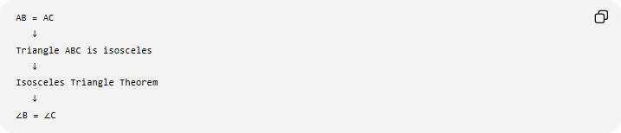
AB = AC
↓
Triangle ABC is isosceles
↓
Isosceles Triangle Theorem
↓
∠B = ∠C
The equality in the given information leads to another equality through deductive reasoning.

Geometric Equality vs Geometric Inequality
# Source: AI Source: Provided by: [Data Path: Persons Table -> ID Column: 1, Name_En Column: Motasem Essam] -> From: [ChatGPT] on [7/25/2026]
These concepts are closely related but fundamentally different.
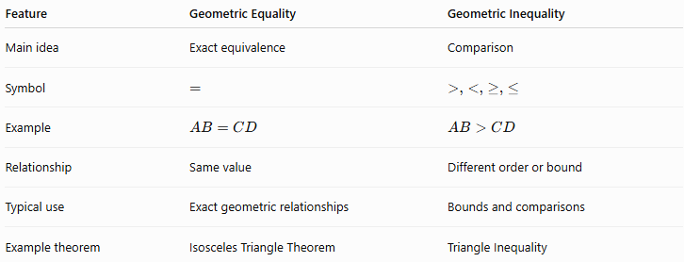
Feature | Geometric Equality | Geometric Inequality
Main idea | Exact equivalence | Comparison
Symbol | $$=$$ | $$>,<,≥,≤$$
Example | $$AB=CD$$ | $$AB>CD$$
Relationship | Same value | Different order or bound
Typical use | Exact geometric relationships | Bounds and comparisons
Example theorem | Isosceles Triangle Theorem | Triangle Inequality
For example:
$$AB=AC$$
states exact equality.
But:
$$AB>AC$$
states an inequality.

Equality vs Congruence
# Source: AI Source: Provided by: [Data Path: Persons Table -> ID Column: 1, Name_En Column: Motasem Essam] -> From: [ChatGPT] on [7/25/2026]
These terms should not be confused.
Equality
Usually compares measurements or quantities:
$$AB=CD$$
meaning:
$$∣AB∣=∣CD∣$$
Congruence
Compares geometric figures having the same shape and size.
$$\boxed{△ABC≅△DEF}$$
Congruence can imply many equalities:
$$AB=DE \\ BC=EF \\ AC=DF \\ ∠A=∠D$$
So:
$$\boxed{\text{Congruence}→\text{Corresponding Equalities}}$$
but:
$$\boxed{AB=DE⇏△ABC≅△DEF}$$
by itself.

Equality Cases in Geometric Inequalities
# Source: AI Source: Provided by: [Data Path: Persons Table -> ID Column: 1, Name_En Column: Motasem Essam] -> From: [ChatGPT] on [7/25/2026]
Geometric equality is particularly important when an inequality has an equality case.
For example, the isoperimetric inequality states:
$$4πA≤P^{2}$$
Equality occurs precisely for a circle:
$$\boxed{4πA=P^{2}}$$
Similarly, Euler's triangle inequality:
$$R≥2r$$
has equality for an equilateral triangle:
$$\boxed{R=2r}$$
Thus equality often identifies a special geometric configuration.

Important Equality Properties

Reflexive Property
# Source: AI Source: Provided by: [Data Path: Persons Table -> ID Column: 1, Name_En Column: Motasem Essam] -> From: [ChatGPT] on [7/25/2026]
Every quantity equals itself:
$$\boxed{a=a}$$
Geometrically:
$$\boxed{AB=AB}$$

Symmetric Property
# Source: AI Source: Provided by: [Data Path: Persons Table -> ID Column: 1, Name_En Column: Motasem Essam] -> From: [ChatGPT] on [7/25/2026]
If:
$$a=b$$
then:
$$\boxed{b=a}$$
For segments:
$$AB=CD⇒CD=AB$$

Transitive Property
# Source: AI Source: Provided by: [Data Path: Persons Table -> ID Column: 1, Name_En Column: Motasem Essam] -> From: [ChatGPT] on [7/25/2026]
If:
$$a=b$$
and:
$$b=c$$
then:
$$\boxed{a=c}$$
For segments:
$$AB=CD, CD=EF$$
therefore:
$$\boxed{AB=EF}$$

Substitution Property
# Source: AI Source: Provided by: [Data Path: Persons Table -> ID Column: 1, Name_En Column: Motasem Essam] -> From: [ChatGPT] on [7/25/2026]
If:
$$a=b$$
then one can replace $a$with $b$in an expression.
For example:
$$AB=CD$$
and:
$$AB+EF=20$$
therefore:
$$\boxed{CD+EF=20}$$

Classification Summary
# Source: AI Source: Provided by: [Data Path: Persons Table -> ID Column: 1, Name_En Column: Motasem Essam] -> From: [ChatGPT] on [7/25/2026]
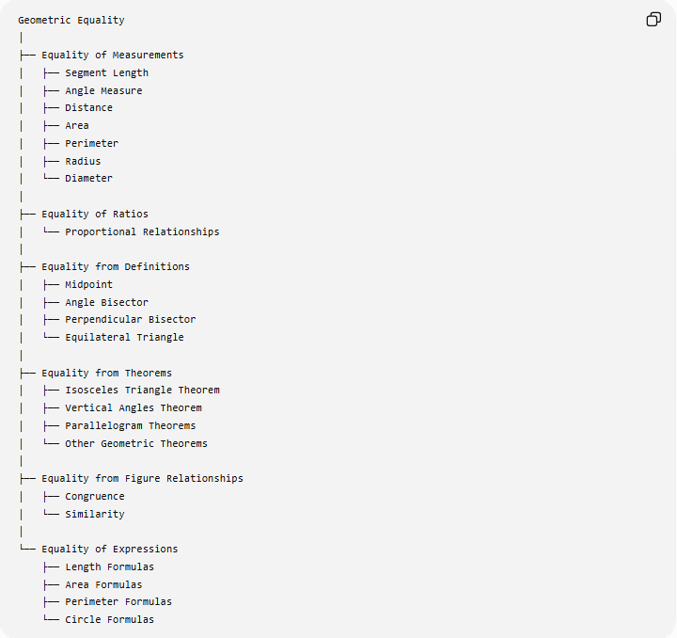
Geometric Equality
│
├── Equality of Measurements
│ ├── Segment Length
│ ├── Angle Measure
│ ├── Distance
│ ├── Area
│ ├── Perimeter
│ ├── Radius
│ └── Diameter
│
├── Equality of Ratios
│ └── Proportional Relationships
│
├── Equality from Definitions
│ ├── Midpoint
│ ├── Angle Bisector
│ ├── Perpendicular Bisector
│ └── Equilateral Triangle
│
├── Equality from Theorems
│ ├── Isosceles Triangle Theorem
│ ├── Vertical Angles Theorem
│ ├── Parallelogram Theorems
│ └── Other Geometric Theorems
│
├── Equality from Figure Relationships
│ ├── Congruence
│ └── Similarity
│
└── Equality of Expressions
├── Length Formulas
├── Area Formulas
├── Perimeter Formulas
└── Circle Formulas

Key Points
# Source: AI Source: Provided by: [Data Path: Persons Table -> ID Column: 1, Name_En Column: Motasem Essam] -> From: [ChatGPT] on [7/25/2026]
- Geometric equality expresses an exact relationship.
- Its principal symbol is:
$$\boxed{=}$$
- Equality can compare lengths:
$$AB=CD$$
- It can compare angles:
$$∠A=∠B$$
- It can compare distances:
$$PA=PB$$
- It can compare areas:
$$A_{1}=A_{2}$$
- It can compare perimeters:
$$P_{1}=P_{2}$$
- It can compare ratios:
$$\frac{a}{b}=\frac{c}{d}$$
- Definitions such as midpoint and angle bisector directly produce equalities.
- Congruent figures produce corresponding equalities.
- Similar figures produce equal angles and proportional side lengths, but not necessarily equal corresponding side lengths.
- Equality is frequently used as a fundamental step in geometric proofs.

Conclusion
# Source: AI Source: Provided by: [Data Path: Persons Table -> ID Column: 1, Name_En Column: Motasem Essam] -> From: [ChatGPT] on [7/25/2026]
Geometric Equality is the exact mathematical relationship between geometric quantities, measurements, expressions, or corresponding parts.
Its fundamental form is:
$$\boxed{A=B}$$
It appears throughout geometry in relationships such as:
$$\boxed{AB=CD} \\ \boxed{∠A=∠B} \\ \boxed{PA=PB} \\ \boxed{A_{1}=A_{2}}$$
and:
$$\boxed{\frac{a}{b}=\frac{c}{d}}$$
Geometric equality is fundamental to definitions, constructions, congruence, similarity, geometric proofs, formulas, and equality cases of geometric inequalities.
A useful next step would be to organize Geometric Equality into its more formal subtopics, such as Segment Equality, Angle Equality, Area Equality, Distance Equality, and Equality Theorems.

